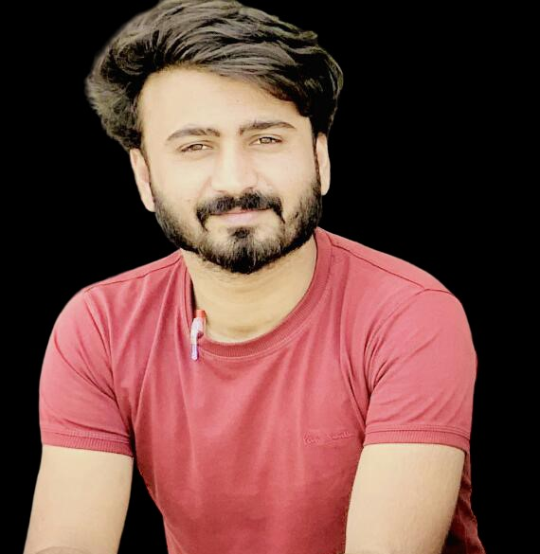 |  | Dear Brian Bjelde,  I hope this letter finds you well. I am writing to express my sincere interest in the Software Engineer position at SpaceX, as advertised on your company website. I have attached my resume for your review, and I would like to draw your attention to additional content that provides a more comprehensive overview of my skills and experiences.
Tariq Mehmood  A Software Engineer  Multan,  Pakistan  03264848783  https://tariqmehmood1004.github.io/  Johnbrrighte7427206@gmail.com |  | Portfolio Highlights:  1. Face Recognition Project: Developed a robust face recognition system incorporating machine learning and image processing techniques, showcasing my proficiency in AI.  2. C# Projects: Demonstrated my programming expertise through various C# projects, including desktop applications that highlight my attention to detail and commitment to delivering user-friendly solutions.  3. Mobile Apps: Contributed to the development of mobile applications, displaying adaptability and a keen understanding of the mobile development landscape.  4. Python Programming: Proficient in Python programming with experience in diverse projects, reflecting my versatility in handling different programming languages.  While my professional journey is just beginning, I am eager to apply my theoretical knowledge and hands-on experience to contribute to the innovative and groundbreaking projects at SpaceX. I am confident that my skills align with the requirements of the Software Engineer role.  Thank you for considering my application. I am enthusiastic about the opportunity to discuss how my background and passion for technology can contribute to the success of SpaceX. I look forward to the possibility of an interview.  Warm Regards,  Tariq Mehmood

